**Lesson 4 Demo 4**

**Push file to GitHub Repository**



Steps to be followed:

1. Create a GitHub repository
2. Create a repository on the local machine
3. Push the changes from the local repository to GitHub
4. Check the status of the local and remote repository

**Step 1: Create a GitHub repository**

1.1 Go to **github.com,** and log in to your account.

1.2 Click on the **New** button to create a new repository, and enter a repository name and click on **Create Repository** button



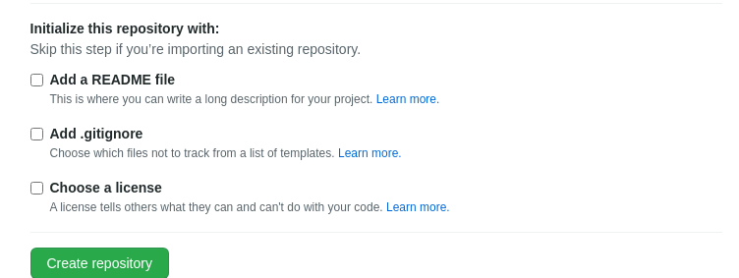

**Step 2: Create a repository on the local machine**

2.1 In the terminal, execute the following commands to create and initialize a Git repository

***mkdir createnewproject***

***cd createnewproject***

***echo "# create new file for my project" >> README.md***

***git init***

***git add README.md***

***git commit -m "first commit"***

***git branch -M main***

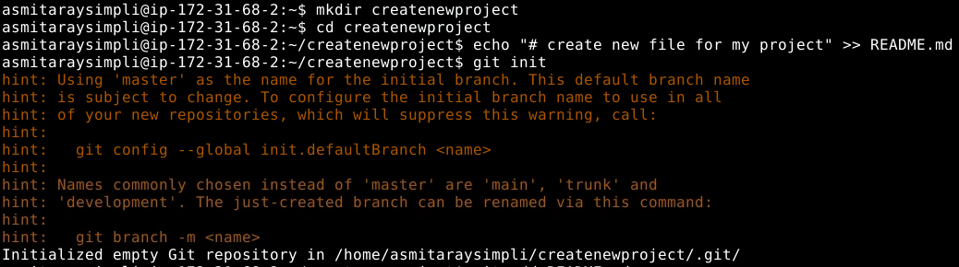

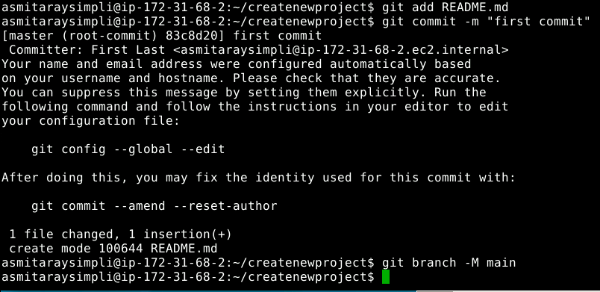

**Step 3: Push the changes in the local repository to GitHub**

3.1 Open the **Terminal** on the local machine, and use the following command to add a remote repository:

**git remote add origin <Your HTTPS_URL>**

3.2 Use the following command to push the changes to the remote repository:

***git push -u origin main***

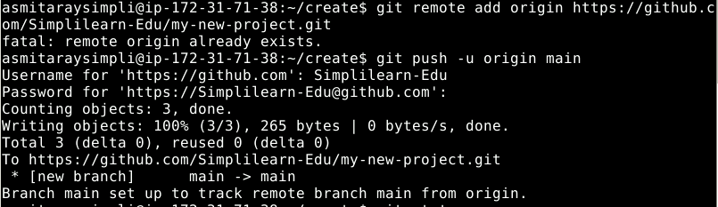

**Step 4: Check the status of the local and remote repository**

4.1 Run the following command to check the status of the local repository

***git status***



4.2 Go to **github.com,** and check the remote repository

